Structural diagrams:

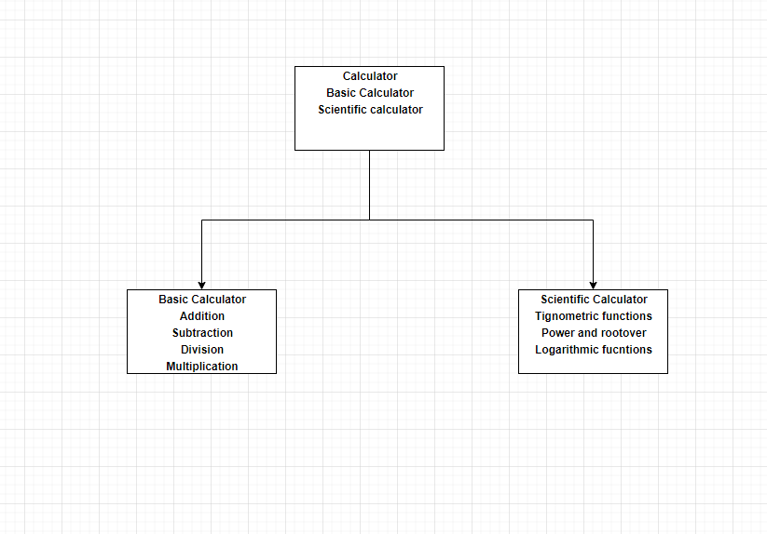

CLASS DIAGRAM 1

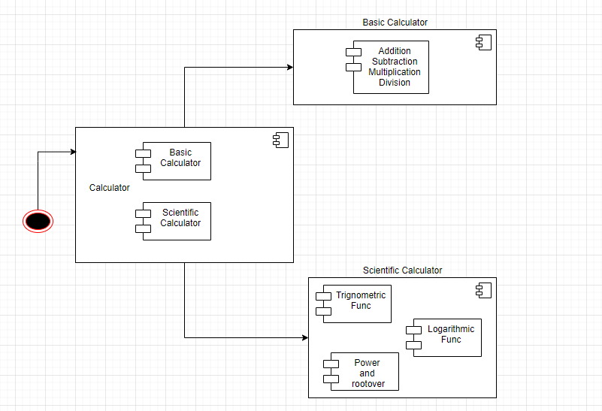

COMPOSITE STRUCTURE DIAGRAM